THE WILBUR BOATHOUSE
4200 S. Peninsula Drive
Wilbur-by-the-Sea, Fla. 32127
386 761 4446

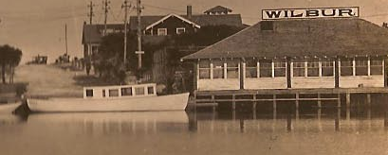

It was a pleasure speaking to you regarding renting the historic Wilbur Boathouse.

Enclosed please find information and documentation necessary for said rental. Please read, completely and carefully and return the appropriate forms to us along with your deposit check. If you have any questions, please resolve them with the WIA representative prior to signing the agreement. Please understand your date cannot be held without your Rental Agreement Signature page and your check back to the Wilbur Improvement Association.

The following documents have been enclosed.

- Boathouse Flyer and Rental Fees – Please share with your friends and family (pgs. 1 – 4)

- Rental Agreement – Please keep for your records (pgs. 5 - 9)
- Rental Agreement Signature Page – Please fill out and return with your deposit (p. 10)

- The Building Management Committee Approval sheet (pg. 11)
- Drawing of Deck, Meeting Room and Annex (pg. 12)

- The Boathouse inspection Checklist (pg. 13)

- Qualified third-party vendor list (pg. 14).

Please do not hesitate to contact the Wilbur Boathouse with any questions at (386) 761- 4446.

Wilbur Improvement Association
- A 501© 4 non-profit organization
- EIN: 59-2388702

THE WILBUR BOATHOUSE
1913

4200 South Peninsula Drive
Wilbur by the Sea, Florida
(386) 761-4446
(1.5 miles South of Dunlawton Ave. on the Halifax River)

Rentals for Weddings, birthdays, Reunions, Anniversaries and Private Parties.

Located directly on scenic Wilbur Bay in the quiet community of Wilbur by the Sea, our building has undergone a complete restoration and will provide a quality location with all of the charm and intimacy that your special occasion or meeting deserves.

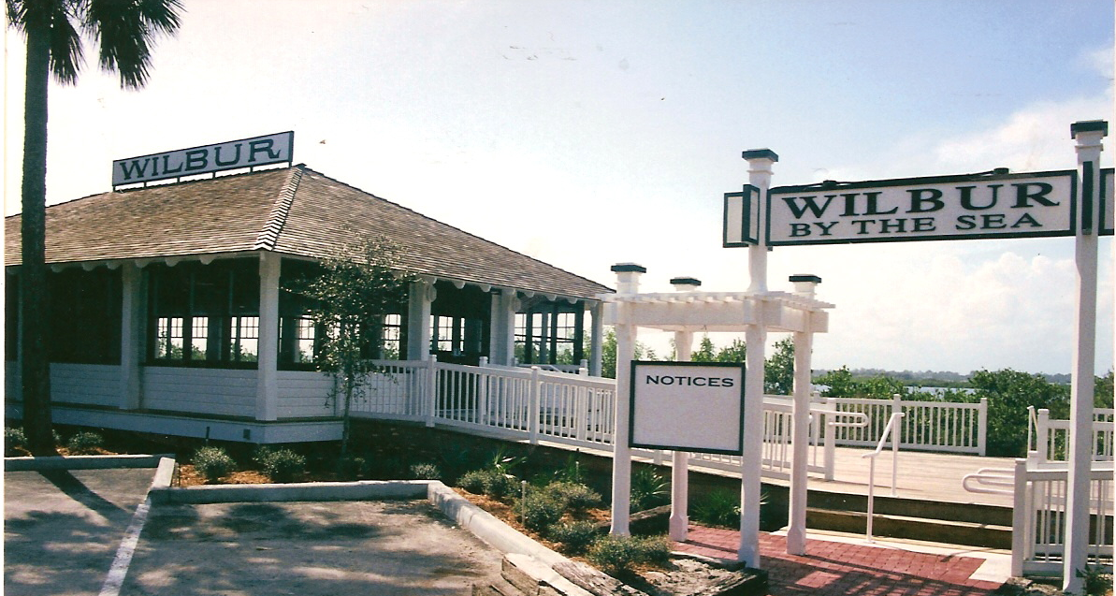

The Wilbur Boathouse provides you with:
- 1500 square feet of interior floor space for dining, dancing and meetings.
- Central heat and air conditioning
- 1500 square feet of outdoor Wharf (deck)
- Plenty of parking within a short stroll
- Perfect for catered occasions
- Fully handicapped accessible

For additional information about renting this brand new, but century old Facility please call and leave a message; (386) 761 4446, or e-mail us at www.wilburboathouse.com. We will return your call quickly with information about the Facility, rates and availability.

THE WILBUR BOATHOUSE
RENTAL FEES
FOR 2017 & 2018

Prime Time is Friday, Saturday, Sunday or Federal Holiday from 8:00 A.M. to 11:00 P.M.

Rental Fee: For any Event is $1,750.00 per day + Tax

Two (2) consecutive days can be reserved for a Prime Time Event for a total of $2,625.00 + Tax

Non-Prime Time is Monday through Thursday from 8:00 A.M. to 11:00 P.M.

Rental Fee: For any Event is $1,650.00 per day + Tax

Two (2) consecutive Non-Prime Time days (8:00 A.M. to 11:00 P.M.) can be reserved for a total 0f $2,475.00 + Tax

Payment of Fees:
All Rental Fees and Damage Security Deposit monies shall be paid in accordance with details of the rental agreement.

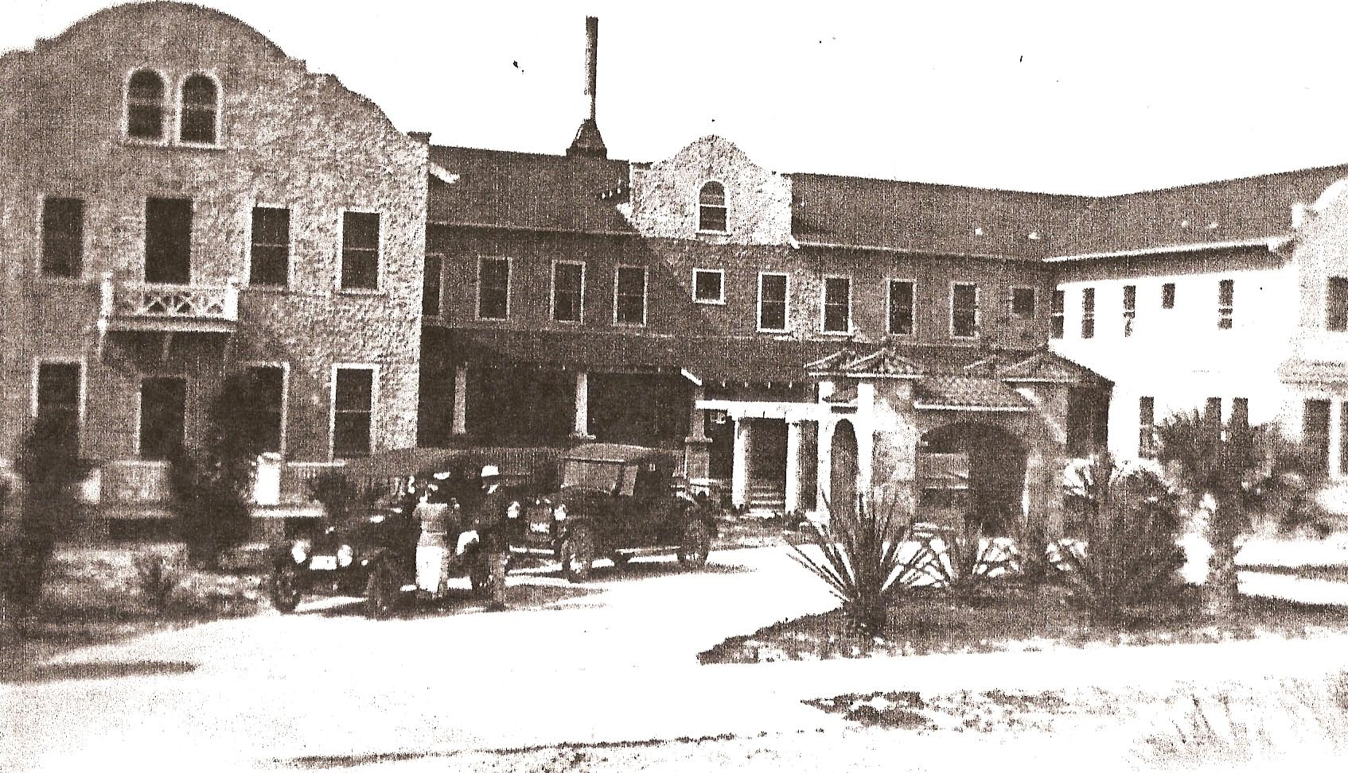

In 1913, Jacob W. Wilbur, a Brookline, Massachusetts real estate dealer, built a pavilion to serve as an office for the Wilbur Land Co., a barber shop, restroom and a meeting place for the residents of Wilbur-by-the-Sea. A wooden landing stage was added for the use of boats to go fishing and to travel to New Smyrna, Ponce Park and Daytona Beach. The BoatHouse was built as part of Jacob Wilbur’s 500 acre seaside resort that consisted of a 50 room hotel (Photo above), 25 cottages, a large garage, stable and carriage shed, laundry, water tower and general store complete with post office. With the exception of a few remaining cottages, the BoatHouse is the last building associated with the original Toronita Hotel complex. Wilbur became known for his seasonal boating parties held at the BoatHouse.

The BoatHouse was in continued use by the community until its near destruction caused by time, floods and storms. The County Council of Volusia along with the Metropolitan Planning Organization approved a grant to completely restore the Wilbur BoatHouse.

Renovation to the historic 1500 square foot BoatHouse began August 14, 2000 and was completed for its grand re-opening on December 1, 2001. Considered to be “absolutely the most beautiful building on the entire South Peninsula”, the Wilbur Boathouse is once again an active community focal point in Wilbur-by-the-Sea.

CATEGORY III

Event Rental Agreement
FOR THE

Wilbur Boathouse Facility

This Agreement (the “Agreement”), is by and between the Wilbur Improvement Association (the “WIA”), whose business address is 4200 South Peninsula drive, Wilbur by the Sea, Florida and the Renter (the “Renter”), and collectively (the “Parties”).

WHEREAS, Renter wishes to use the WIA’s facility for an Event (the “Event”);

In consideration of the mutual promises and covenants contained herein, the Parties agree as follows:

1. Facility Rental. The WIA hereby grants to Renter a limited and revocable use of the following facility: the Wilbur Boathouse, attached exterior wood deck, and annex building containing bathrooms. The agreement permits Renter to use the Facility only on the Event date, during the hours specified below, and only for the purposes set forth in Section 9 below.

2. In no case shall the Renter be given permission to extend the event beyond 11 P.M.
- Every person along with all of their equipment and belongings must be off the premises by 11 pm. No Exceptions.
- If Renter has not ended their event, including clean-up by 11 pm the security/damage deposit is forfeited.

3. Payment of fees and/or cancellations. Renter shall pay to the WIA a Rental Fee for the use of the Facility, plus a Damage Security Deposit of $300.00.
- Upon execution of this Agreement the renter must pay to WIA, 50% of the total Rental Fee, which is non-refundable.
- The remaining 50% of the Rental Fee plus the Damage Security Deposit is due in full 60 days prior to the Event Date, (the “Payment Due Date”). If Renter fails to pay the full Rental Fee by the Payment Due Date, a late fee equal to 5% of the rental fee will be assessed. Also, the WIA shall have the right to revoke the Agreement and to keep the full amount all monies already paid. If payment is not made the full 60 days ahead of the event, only cash will be accepted after that deadline.
- If Renter cancels the reservation for the Event after payment of the full Rental Fee and Damage Security Deposit, the WIA shall refund to the Renter the Damage Security Deposit plus ½ of the facility rental charge.

4. Conditions of Premises. The WIA shall make sure that the Facility conforms to the following specifications by the Event Date:
- Use of Facility and listed items as delineated by “Drawing of Deck, Meeting Room and Annex”.
- Aside from the specifications set forth above, the Facility shall be provided as-is, and the WIA makes no warranty to Renter regarding the suitability of the Facility for Renter’s intended use.
- The Renter and the WIA shall follow the guidelines below regarding Set-up, Teardown and Cleaning of the Facility:

5. Sub-contract vendors. If the renter intends to use third party sub-contractors to provide wedding planning services, food catering, tables and chairs and/or outside event tents, the sub-contractor shall provide:
- Valid business license for Volusia County, Florida
- Certificate of insurance for liability and workers compensation.
- The license and insurance certificates must be provided to the Boathouse prior to the event date. Insurance certificates must be sent directly to the Boathouse by the insurance provider.
As a convenience to the renter, the Wilbur Boathouse provides a list of qualified vendors who have their license and insurance certificates on file with the Boathouse. Use of these vendors relieves the renter of the burden of providing the required documentation. The Wilbur Boathouse cannot certify the performance of these vendors. However, we do certify that we receive no compensation of any kind from the vendors listed. The vendor list is on page 14 of this agreement.

6. Renters Responsibility:
- All set-up.
- Return outside chairs and tables to Meeting Room (Do Not Stack or Store).
- Remove food, decorations and personal items. (Food, decorations or personal items will be discarded if left in the Facility after the Event).
- All outside litter should be picked up and put into trash containers.

7. WIA’s responsibility:
- Prior to the Event the Facility shall be clean, chairs and tables shall be folded and stored in the meeting room and all included equipment shall be made available to Renter.
- After the Event general cleaning consisting of gathering and disposing of trash left on top of tables, wiping down and folding and storing tables and chairs, sweeping and mopping the meeting room, annex and kitchen floors, washing and storing equipment and removing trash from the Facility. Note: Extensive cleaning, above and beyond the items described above, will be reason for the WIA to recover cost of same from the Renter. Such additional cost may be deducted from the Damage Security Deposit.
- Review with the renter and have the renter sign, prior to the event, “The Boathouse inspection Checklist”. Renter shall be responsible for any damage caused to the Facility beyond ordinary wear and tear. The WIA shall be entitled to arrange for any necessary repairs at Renter’s expense. Renter shall reimburse the WIA for any such repairs, first from the Security Deposit and then, any cost of repair or clean up over the Security Deposit amount will be itemized, billed to the Renter, and the additional payment to the WIA will be due upon receipt.

8. Rules. An Event may be terminated if the conditions stated in this agreement are not met. WIA agrees to comply with all state and federal laws and will not discriminate against any person because of race, religion, color, sex, disability, national origin or ancestry or age.
- The Renter must make it perfectly clear and publicized that the opinions they express are strictly their own and do not reflect the opinions of the Volusia County Government or the Wilbur Improvement Association.
- Once the building is unlocked and available to the renter, the renter is required to have a responsible person on the premises as long as the building is unlocked.
- Renters are granted use only of the Facility and are responsible for supervising all the participants in their group so as not to interfere with other on-going activities, programs and neighboring residents.
- Table and chair set-ups are not to block any exit doors or doors to other rooms. Normal pedestrian and vehicular access will not be altered.
- No smoking is allowed in the meeting room, kitchen and annex. Please take care to use ash cans located outside and off the deck. Fireworks including sparklers are not permitted anywhere.
- The Wilbur Boathouse Facility is located in a residential neighborhood. Accordingly, live music or a DJ’s music must be played inside the Facility and no voice or music amplifiers may be placed outside on or off the deck. If any noise amplifiers are used, the windows will remain closed. Complaints, from the Wilbur community, of loud noise/music, especially loud bass being played could result in the music being stopped and you could be asked to leave the property.
- Alcohol may be served, but not sold in any manner.
- Renter fully guarantees and is totally responsible to insure that no alcohol will be dispensed to or consumed by minors.
- Renter is responsible for hiring and supervision of security or safety personnel if they are required.
- Trash and Refuse: Garbage bags are provided in all Boathouse provided trash receptacles. At the end of the event, garbage bags that have been properly tied with the attached draw strings may be placed in the outside storage contained. If the bags are not used and tied properly (Loose trash placed into the storage container outside of garbage bags.) you will be subject to a charge of up to $50 to be deducted from your security deposit.
- Parking is limited at the Facility. Additional public parking is available at the Southwest corner of Toronita and S. Atlantic Ave.
- Decorations or any other item may not be attached to the fans, walls, roofing or ceiling and nails, pins or other attachment devices. Tape may not be used. Loose floor decorations, such as balloons, rice, birdseed, etc. are not permitted for safety concerns.
- There will be no physical alteration of the building structure, Facility or appurtenances thereof. An Event will be terminated if the conditions of this Agreement are not met or if it is deemed in the best interest of the Wilbur Improvement Association in the opinion of the WIA’s representative. If an Event is terminated, the Renter and all in the Renter’s group agree to leave the Boathouse immediately. If an Event is terminated, all fees will be forfeit.

9. Right of Entry. A representative of WIA shall have the right to enter the Facility at any time for any reasonable purpose, including any emergency that may threaten damage to the WIA’s property, or injury to any person in or near the Facility.

10. Indemnification. The Renter group hereby agrees to save, indemnify and hold harmless the Wilbur Improvement Association and the County of Volusia, its agents and employees or sub-contractors, from any and all claims, damages, suits at law or equity of whatever kind of nature for damages to or loss of property or injury or death to persons, resulting directly or indirectly from or attributable to the Renter, its’ guests, its’ employees or sub-contractors in connection with the Event authorized by this Agreement. The Renter’s group is responsible for complying with all applicable Volusia County, Florida and Federal laws and regulations that apply to the specific activity and will comply regarding the safety of persons and property, or their protection from damage, injury or loss. Renter shall notify the WIA of any damage or injury of which it has knowledge in, to, or near the Facility, regardless of the cause of such damage or injury.
.
11. Permitted Use. Renter is authorized pursuant to the Agreement to use the Facility to hold the Event, and for no other purpose. Renter may not use the Facility in any manner that may render the insurance for the Facility or upon any of the WIA’s property void, or which may result in increased insurance premiums for the WIA with respect to the Facility or any other of the WIA’s property.
Use of the Space shall be at the Renter’s own risk

- Event dates are approved on a first come first serve basis. Scheduled Event dates are not transferable.
- The signer of the Agreement will be the liaison and contact between the Renter and the WIA concerning changes, alterations, decisions and the operations of the scheduled Event.
- A Renter may specify a Designee to act on their behalf for the Event.
- Loitering in the Facility after an Event is not allowed
- The WIA is not responsible for Renters, or their guests, items damaged, stolen of left at the Facility.
- All event set-up and clean-up by the renter or it’s sub-contractors, must take place during the designated rental times; 8:00 a.m. – 11:00 p.m.

12. Compliance with Laws. Renter shall obtain and maintain any necessary permits, licenses, or other forms of permission necessary to use the Facility according to the permitted uses set forth in Section 9 in a lawful manner. Renter shall not use the Facility in any manner that would violate local, state or Federal laws or regulations. Renter hereby indemnifies WIA, its employees, officers, directors, or other agents for any damages, penalties, fines, suits, actions, or other cost (including reasonable attorneys’ fees) arising out of or in connection with Renter’s violation of any local, state or federal law, rule, regulation or ordinance related to Renter’s use of the Facility.
If alcoholic beverages are to be served during the Event the Renter accepts full responsibility and liability for the actions of all participants attending the Event and the results of said actions. The Renter also understands all alcohol is to remain within the Facility and that guests consuming alcohol in the surrounding park could be arrested for public alcohol consumption. The Renter understands that if these conditions are not met, the Agreement is revoked immediately with no money refunded. The Renter agrees that no alcohol will be sold, in any manner, during the Event and accepts full responsibility for the actions of all participants attending the Event and the results of said actions.

13. Force Majeure. In the event that the WIA is unable, for reasons beyond its control, to make the Facility available to Renter on the Event Date for the purposes as set forth in this Agreement, Renter shall have the option of choosing an alternate date to hold the Event (the “Alternate Event Date”), at no extra charge to Renter.
- If Renter selects an Alternate Event Date that is available, reasonable and acceptable to the WIA, then the Alternate Event Date shall replace the Event Date for the purposes of this Agreement, and all obligations, rights, duties and privileges as set forth in this Agreement shall remain binding on the Parties.
- If Renter and the WIA cannot agree upon an Alternate Event Date within 30 days of the original Event Date, then the WIA shall refund to Renter the full amount of the Rental Fee (including the full Deposit).
- In neither case shall the WIA be liable for any additional costs or damages suffered by Renter (over and above the Rental Fee) arising out of a rescheduling or cancellation of the Event pursuant to this section.

14. Assignment. Neither party may assign or transfer their respective rights or obligations under this Agreement without prior written consent from the other Party.

15. Governing Law. This Agreement shall be construed in accordance with, and governed in all respects by, the laws of the State of Florida, without regard to conflicts of law principles.

16. Counterparts. This Agreement may be executed in several counterparts, each of which shall constitute an original and all of which, when taken together, shall constitute one Agreement.

17. Severability. If any part or parts of this Agreement shall be held unenforceable for any reason, the remainder of this Agreement shall continue in full force and effect. If any provision of this Agreement is deemed invalid or unenforceable by any court of competent jurisdiction, and if limiting such provision would make the provision valid, then such provision shall be deemed to be construed as so limited.

18. Notice. Any notice required or otherwise given pursuant to this Agreement shall be in writing and mailed, or delivered by overnight delivery service.

19. Headings. The headings for sections herein are for convenience only and shall not affect the meaning of the provisions of this Agreement.

20. Entire Agreement. This Agreement constitutes the entire Agreement between Renter and The WIA, and supersedes any prior understanding or representation of any kind preceding the date of this Agreement. There are no other promises, conditions, understandings or other agreements, whether oral or written, relating to the subject matter of the Agreement.

The Wilbur Boathouse Rental Agreement Signature Page

Renters Name:________________________________________________________________
Renters Address: ______________________________________________________________________________
______________________________________________________________________________
Phone Number: Land Line ( )__________________ Cell Phone ( )______________________
E-Mail Address _________________________________________________________________________
Type of Event _______________________________
Estimated Number of Attendees ________
Event Date ________________
Starting time of Event ___________ Ending Time _______________

Rental Fee and Deposit
Base Rental Fee $________
6.5% Sales Tax $________
Total Rental Fee with Tax $________
Plus Security Deposit $___300.00
Total Rental Fee, Tax and Security Deposit $________
Less Deposit Fee (50% of Total Rental Fee) $<______> (due at signing of Agreement)
Remaining Total Rental Fee and Security Deposit $________ Due Date _____________

- Make checks payable to Wilbur Improvement Association and mail together with this page to:
Wilbur Improvement Association
4200 S. Peninsula Drive
Wilbur by the Sea, Florida 32127

- By signing this page the Renter acknowledges the existence of the entire Agreement consisting of: The Cover Page (pg 1), The Agreement (pgs 2 – 5), the Rental Fee sheet (pg 10), this page (pg 11), The Building Management Committee Approval sheet (12)and The Boathouse inspection Checklist (pg 13).

Renter:________________________________ ___________________________________
(Signature) (Print)
Designee: ________________________________ ___________________________________
(Signature) (Print)
Designee Phone Number: Land Line ( )________________Cell Phone ( )________________
Date Agreement Received ________________

Building Management Committee Representative
Is there a prior application for this Event Date? _____ Yes _____ No
Date Agreement Approved ________________

_______________________________________________
(Signature)Building Management Committee Representative
Agreement Not Approved ____ Why? ______________________________________________________________________________
Applicant has three (3) days to repair and resubmit a disapproved Agreement to maintain a priority claim for the Event Date.

Returned Agreement
Date Agreement Approved ________________ __________________________________________________
(Signature) Building Management Committee Representative

Agreement Not Approved ____ Why? _____________________________________________________________________________

“Drawing of Deck, Meeting Room and Annex”

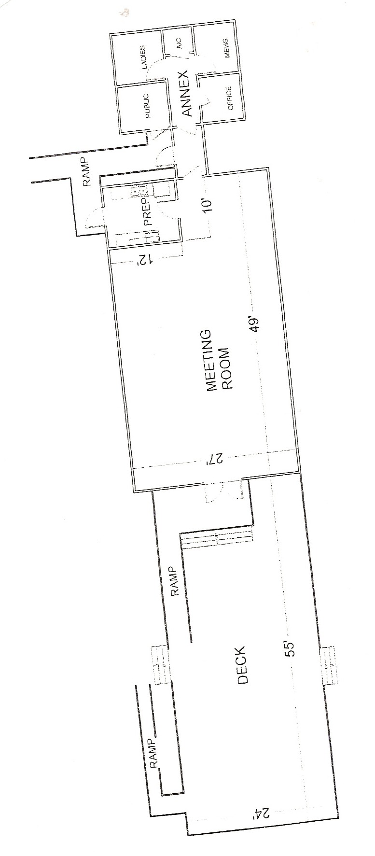
The Facility includes 8 ea. Parking Spaces on site with additional public parking on the Volusia County Lot at the corner of Toronita and S. Atlantic Ave.

The Boathouse Inspection Checklist

This checklist will be provided to the Renter by the WIA’s representative for review and signature prior to and after the Event. This checklist covers items of possible damage for examination after the Event when it will be reviewed with the Renter.

Prior to the Event and again after the Event the Renter and The WIA’s representative shall inspect the Facility and note any damage that may be visible.

Inspect for condition: | Prior to Event | After Event
1. Windows | ____YES____NO | ____YES____NO
2. Floors | ____YES____NO | ____YES____NO
3. Tables | ____YES____NO | ____YES____NO
4. Chairs | ____YES____NO | ____YES____NO
5. Doors and Locks | ____YES____NO | ____YES____NO
6. Restrooms | ____YES____NO | ____YES____NO
7. Refrigerator | ____YES____NO | ____YES____NO
8. Kitchen Counters | ____YES____NO | ____YES____NO
9. Lights and Fans | ____YES____NO | ____YES____NO
Initials | _______________ | _______________

Inventory
11 ea. 8’ tables | ____YES____NO | ____YES____NO
4 ea. 6’ tables | ____YES____NO | ____YES____NO
80 ea. chairs | ____YES____NO | ____YES____NO
1 ea. 38” circular table | ____YES____NO | ____YES____NO
1 ea. 18” by 60” wooden table | ____YES____NO | ____YES____NO
1 ea. micro-wave oven | ____YES____NO | ____YES____NO
4 ea. 30 gallon trash Cans | ____YES____NO | ____YES____NO
2 ea. Kitchen trash cans | ____YES____NO | ____YES____NO
2 ea. Bathroom trash cans | ____YES____NO | ____YES____NO
 | ____YES____NO | ____YES____NO
 | ____YES____NO | ____YES____NO
Initials | _______________ | _______________

Renters Signature ________________________________________________________________________

WIA’s Representative Signature ____________________________________________________________

Wilbur BoatHouse qualified vendors

The following sub-contract vendors currently have their certificates of insurance and business license on file with the Wilbur Boathouse for the calendar year 2014. We provide this list to the renter to help relieve the burden of providing the required insurance certificates and licenses. However, the Wilbur Boathouse cannot guarantee the performance of these vendors. The Wilbur Boathouse does not receive compensation in any form from the listed vendors or their affiliates. It is the responsibility of the renter, should they elect to use any of the vendors listed, to negotiate their own terms of performance and payment directly with the vendor.

Wedding Planners
- Seaside Ceremonies (Pam) 386-235-1549

Cleaning Services
- Sweet Pea Sweeps Yvonne Widman 386-366-3534

Food Caterers:
- Aunt Catfish’s on the River (Jeff Marshall) 386-767-4768
- Caton Catering 386-295-1104
- Daytona Pig Stand (Shane) 386-898-0360
- Flip Flops to Formal (Shauna) 386-255-3464
- Encore Catering 386-943-8520
- RPS Catering(Trish Scuteria) 386-295-0366

Outside Event Tents, Tables, Chairs, Etc.:
- Above All Tent Rental (Ron Woodfine) 386-761-1732
- Special Event Services 386-760-6111
- Coastal Vintage Rentals www.coastalvintagerentals.com

Photography
- Emotive Photo (Meagan) 386-214-1190 www.emotivephoto.com
- Leah Dorr Photography 757-771-8987 leahdorr@yahoo.com

